**Name: MODALLA PRANITH REDDY**

**Roll no: 2420030158**

**Lab 8**

**Configure Static Routing using a Cisco network switch and verify the connectivity**

**Static routing**

**Step 1:** Connecting the devices

# Routers:

* Select two routers of type 1841
* Connect both routers using the Copper-Cross over cable

# Switches:

* Select two switches of type 2950-24
* Connect the Switch0 with Router0 with ports F0/0
* Connect Switch1 with Router1 with ports F0/1

# PC’s:

* Select four PCs
* Connect the first two PCs (PC0, PC1) to the Switch 0 using the Copper straight-through cables.
* 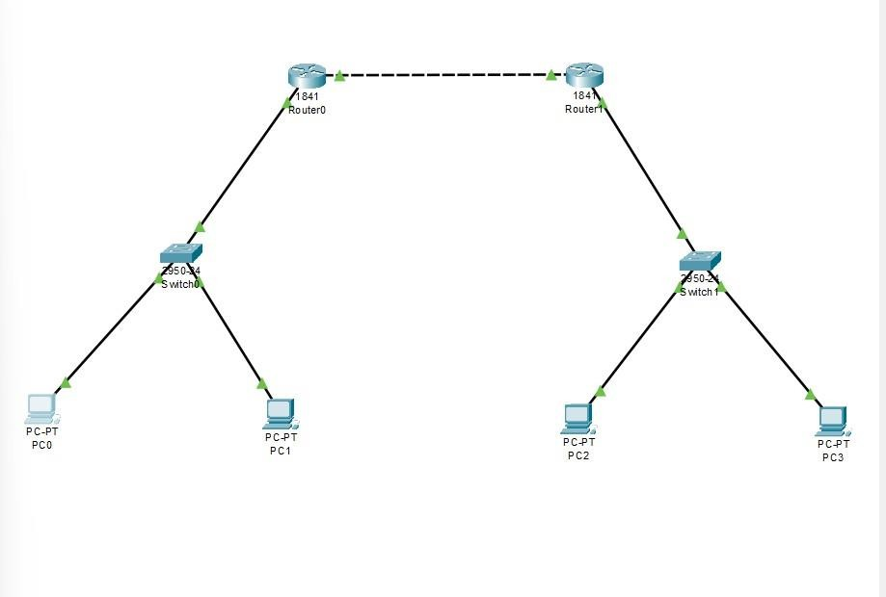Connect the next two PCs (PC2, PC3) to Switch 1 using the Copper straight-through cables.

**Step 2:** Configuring the devices

# Configuration of Routers:

* **Configure the routers with an IP Address**

Router 0:

## F0/0: 192.168.1.2

F0/1: 192.168.2.3

Router 1:

F0/0: 192.168.1.4 F0/1:192.168.3.3

# Configuration of PCS

## PC0:

Ipv4: 192.168.2.7

Subnet mask: 255.255.255.0

Default gateway: 192.168.2.3

## PC1:

IPv4: 192.168.2.9

Subnet mask: 255.255.255.0

Default gateway: 192.168.2.3

## PC2:

IPv4: 192.168.3.5

Subnet mask: 255.255.255.0 Default gateway:192.168.3.3

## PC3:

IPv4: 192.168.3.7

Subnet mask: 255.255.255.0 Default gateway:192.168.3.3

Note: Default gateways are the ones that you give from the router to switches; the same address will be assigned as the gateways to the PCs that are connected to switches.

* Configuration of Router0 in CLI: Router0> enable

Router0# configure terminal

Router0(config)# ip route 192.168.3.0 255.255.255.0 192.168.1.4

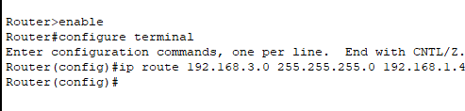

* Configuration of Router1 in CLI: Router1> enable

Router1# configure terminal

Router1(config)# ip route 192.168.2.0 255.255.255.0 192.168.1.2

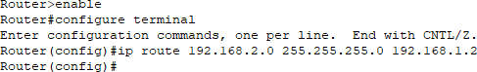

**Step 3: Using the ping command**

* Open the command prompt of PC0
* Type the command **ping 1G2.168.2.G** and check the output.
* 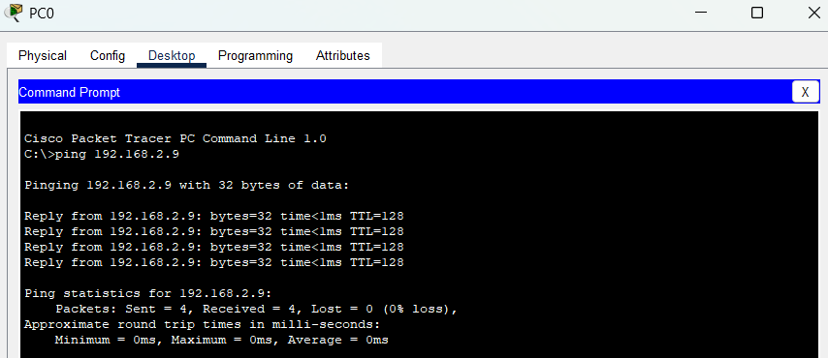Consequently, check the ping commands for the other PCs also.
* Also, try to check the ping command for the last PC (PC3) using the IP address of PC0. If you get the output, then only the experiment is successful.
* If you don’t give the default gateways to the PCs, you won’t get the output.
* Default gateways are the ones that you give from the router to switches; the same address will be assigned as the gateways to the PCs that are connected to switches.
* Ex: Router0 to Switch0: F0/1 = 192.168.2.3 Default gateways of PC0, PC1: 192.168.2.3
* At first, after using the ping command, if you get a request timed out for 2 times and next 2 times you get the output, then it means your connection just started.
* Try the same command again then you will get the correct output.

